# *Fop home task 4*

## Name: Muhammad Usman Bhutto

## Roll no: 453891

**Section: B**

*Home task 1:*

#include<iostream>

using namespace std;

int main()

{

for(int i=1;i<=150;i++){

if(i%10==0){

continue;

}

cout<<i<<" ";

}

return 0;

}

*Output:*

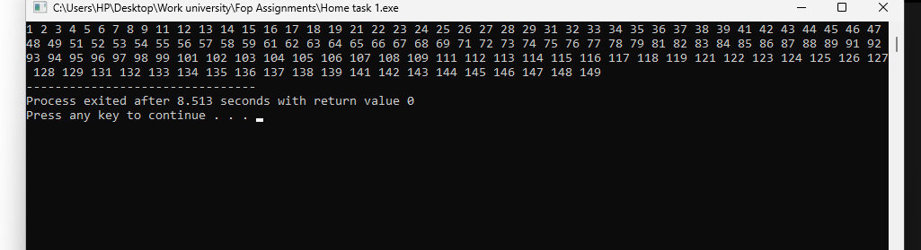

*Home task 2:*

#include <iostream>

using namespace std;

int main() {

int number, sum = 0;

cout << "Enter a number: ";

cin >> number;

while (number > 0) {

sum += number % 10;

number /= 10;

}

cout << "Sum of the digits: " << sum << endl;

return 0;

}

*Output:*

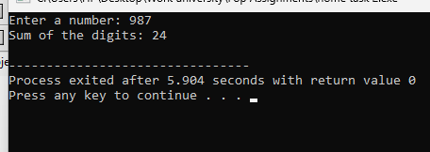

*Home task 3:*

#include <iostream>

using namespace std;

int main() {

int num;

bool isPrime = true;

cout << "Enter a positive integer: ";

cin >> num;

if (num <= 1) {

isPrime = false;

} else {

int i = 2;

while (i * i <= num) {

if (num % i == 0) {

isPrime = false;

break;

}

i++;

}

}

if (isPrime) {

cout << num << " is a prime number." << endl;

} else {

cout << num << " is not a prime number." << endl;

}

return 0;

}

*Output:*

